ҚÀЗАҚСТАН РЕСПУБЛИКАСЫ БІЛІМ ЖӘНЕ ҒЫЛЫМ МИНИСТРЛІГІ  «ESIL UNIVERSITY»  Нұр-Сұлтан қ. | 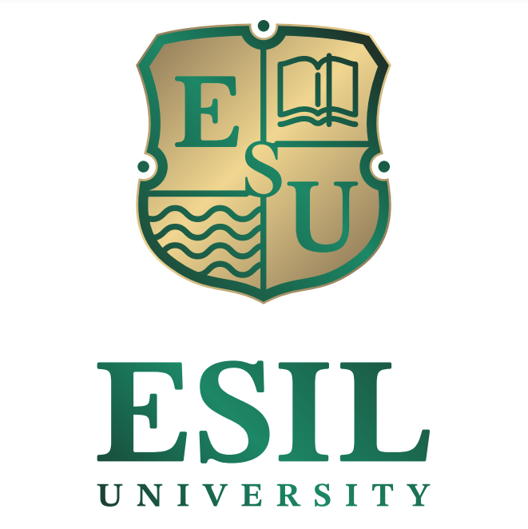 | MINISTRY  OF EDUCATION AND SCIENCE OF THE REPUBLIC OF KAZAKHSTAN  «ESIL UNIVERSITY»  Nur-Sultan

CALL FOR PAPERS

The institution "Esil University" is holding an International scientific and practical conference on the topic on April 22, 2022: "Youth and Science XXI: realities and prospects" for students and undergraduates.
The purpose of the conference: To discuss the current problems of the economy and socio-economic development of Kazakhstan in the face of challenges and a pandemic, to find ways to further develop the country in the field of economics, finance, accounting, auditing, marketing, management, as well as tourism and information technology. In addition, attention will be paid to legal and economic aspects in the field of customs, as well as in the field of social and humanitarian development of society.

The work of conference is planned in the following areas:

1. Diversification and digitalization of business in modern economic conditions;
2. Trends and directions of development of modern management;
3. Money, finance, banking: transformation and prospects;
4. Current trends in the modernization of accounting, audit and evaluation;
5. Trends in the development of marketing and customs services in the context of digitalization;
6. Modern information technologies as a basis for the development of the digital economy of Kazakhstan;
7. Development of the social sphere and sustainable tourism in Kazakhstan;
8. Social and humanitarian problems and tendencies in the development of modern polilingual personality;

Forms of the conference: plenary and breakout sessions, round tables and discussions.
Students of higher educational institutions, students of secondary educational institutions, students of graduating classes of secondary schools of the Republic of Kazakhstan are invited to participate.
Working languages of the conference: Kazakh, Russian, English.
Form of participation: full-time; correspondence.

Important dates:
The deadline for submitting applications with the purpose of participation in the conference is April 18, 2022.
The date of holding the conference is April 22, 2022.

Terms of participation in the conference
To participate in the conference, it is necessary to submit an article to the Organizing Committee at 7 Zhubanova str., Nur-Sultan on paper and in electronic form to the postal address science.esil.2022@mail.ru the following documents:
- application for participation;
-a 3-4-page report, designed according to the requirements listed below.

Procedure for preparing reports
The volume of the report is at least 4 pages, the format is A4, the margins of the page - top and bottom – 2 cm, right -1.5 cm, left - 3cm. The name of the report is typed Times New Roman size 14, bold font. Next, the surname and initials of the author and the supervisor (with regalia), the name of the educational institution, the city are typed. In the center is the title of the article in capital letters, followed by a double-spaced text. The font of the main text is typed in 14 pins, with a single interval, with an indentation of 1.25. References to literature are given at the end of the text in the order of use of materials in the article.
Attached to the report are:
- review of the supervisor;
- abstract (5-7 suggestions) in Kazakh (anda), English (annotation) or Russian, depending on the language of writing the text.
Articles of students, undergraduates, without a supervisor are not included.

A sample of an article
(in the right top)
Akhmetov A.B.,
3rd year student of ‘Economics’ major
Scientific supervisor: Toksanova A.N., Doctor of Economics, Professor,
The institution "Esil University", Nur-Sultan

ECONOMIC GROWTH AS A RESULT OF THE DEVELOPMENT
OF THE NATIONAL ECONOMY
(the article title is located in the centre, written in uppercase and bold font)

Аңдатпа
Аннотация
Аnnotation

Text of article

List of references (according to GOST)

Materials submitted later than the specified deadline or issued not in accordance with the requirements are not considered and are not returned back. The Organizing Committee reserves the right to select articles, the author is responsible for the content of the article.
Participation in the conference for students, undergraduates and secondary school students is free of charge.

Coordinator of the conference: Chief Specialist of the Department of Organization of Research work - Bernazarova Rosa Diyasovna, tel: +7 (7172) 27-85-71 (ext. 118). E-mail: science.esil.2022@mail.ru

Organizing Committee

